FAKE NEWS DECTECTION USING MACHINE LEARNING ALGORITHMS

**DESIGN PROJECT – 2 REPORT**

***Submitted by***

**P. SAI MANOJ (19113101)**

**K. SUMANTH KUMAR REDDY (19113105)**

**P. UMESH CHANDRA (19113118)**

**Under the guidance of**

**DR.R. KRISHNAVENI**

**Professor**

***in partial fulfillment for the award of the degree of***

**BACHELOR OF TECHNOLOGY**

**in**

**COMPUTER SCIENCE AND ENGINEERING**



**HINDUSTAN INSTITUTE OF TECHNOLOGY AND SCIENCE**

**CHENNAI - 603 103**

APRIL 2022



**BONAFIDE CERTIFICATE**

Certified that this project report **“FAKE NEWS DECTECTION USING MACHINE LEARNING ALGORITHMS”** is the bonafide work of “**P. SAI MANOJ (19113101), K. SUMANTH KUMAR REDDY (19113105), and P. UMESH CHANDRA (19113118)”** who carried out the project work under my supervision during the academic year 2**021-2022**.

**DR.R.KRISHNAVENI**,

**SUPERVISOR**

PROFESSOR

Department of CSE.

**INTERNAL EXAMINER EXTERNAL EXAMINER**

Name: Designation:

Name:

Designation:

Project Viva - voce conducted on

**CHAPTER**

**TABLE OF CONTENTS**

**TITLE PAGE NO.**

|  |  |  |
| --- | --- | --- |
| **NO.** |  | |
|  | **Acknowledgement** | **vi** |
|  | **Abstract** | **vii** |
|  | **List of Tables**  **List of Figures** |  |
|  | **List of Abbreviations** |  |
| **1** | **INTRODUCTION** | **1** |
|  | 1.1 Overview | **1** |
|  | 1.2 Motivation for the project | **2** |
|  | 1.3 Organization of the report | **3** |
| **2** | **LITERATURE REVIEW** | **4** |
|  | 2.1 Ternion: An Autonomous Model for Fake News Detection  2.2 Survey on Fake News Detection using Machine Learning Algorithms  2.3 Fakes News Classification based on Content Level Features  2.4 Detecting COVID-19-Related Fake News Using Feature Extraction  2.5 Fake News Detection Using Machine Learning |  |
|  |  |  |

1. **PROJECT DESCRIPTION 6**
   1. Objective of the Project work **6**
   2. Existing System **7**
   3. Shortcomings of Existing System **7**
   4. Proposed System **8**
   5. Benefits of Proposed System **10**
2. SYSTEM DESIGN 11
   1. Architecture Diagram **1****1**

**4.1.1** Workflow **12**

1. PROJECT REQUIREMENTS 13
   1. Hardware and Software Specification **13**
   2. Technologies Used **13**
2. MODULE DESCRIPTION 14
   1. Modules **14**
   2. Login Window **14**
   3. Test Window **14**
   4. Multiple Classifiers **15**
   5. Result Window **15**
3. IMPLEMENTATION
   1. User Interface **16**
4. RESULT ANALYSIS 22
   1. Results obtained **22**
5. CONCLUSION AND FUTURE WORK 27
   1. Conclusion **27**
   2. Future Work **27**
6. INDIVIDUAL TEAM MEMBER’s

REPORT

* 1. Individual Objective **28**
  2. Role of the Team Members **28**
  3. Contribution of Team Members **29**

REFERENCES 30

**APPENDIX A: SAMPLE SCREEN APPENDIX B: SAMPLE CODE**

**APPENDIX C: TEAM DETAILS**

**ACKNOWLEDGEMENT**

First and foremost we would like to thank **ALMIGHTY** who has provided us the strength to do justice to our work and contribute our best to it.

We wish to express our deep sense of gratitude from the bottom of our heart to our guide **Dr.R.Krishnaveni, Professor** ,**Computer Science and Engineering,** for her motivating discussions, overwhelming suggestions, ingenious encouragement, invaluable supervision, and exemplary guidance throughout this project work.

We would like to extend our heartfelt gratitude to **Dr. J.Thangakumar, Ph.D., Professor & Head, Department of Computer Science and Engineering** for her valuable suggestions and support in successfully completing the project.

We thank the management of **HINDUSTAN INSTITUTE OF TECHNOLOGY AND SCIENCE** for providing us the necessary facilities and support required for the successful completion of the project.

As a final word, we would like to thank each and every individual who have been a source of support and encouragement and helped us to achieve our goal and complete our project work successfully.

**ABSTRACT**

This Project is about distinguishing the 'fake news' which is misleading news stories that comes from some fake sites. The advent of the World Wide Web and the rapid adoption of social media platforms (such as Facebook and Twitter) paved the way for information dissemination that has never been witnessed in the human history before.

With the current usage of social media platforms, consumers are creating and sharing more information than ever before, some of which are misleading with no relevance to reality. It is conceivable just developing a model dependent on a count vectorizer (using word tallies) or a (Term Frequency Inverse Document Frequency) Tf-idf matrix, (word tallies will help us in the matter which is relative in other news websites which is based on given database set) can only get you so far.

Comparing the fake news with real ones sometimes need a good of knowledge on that topic. Can we find which fake or real news is? Along these lines, we propose work on accumulate a dataset of both fake and genuine news and carrying out a Passive Aggressive classifier to make a model to classify any news that may be fake or real will be checked based on its words and phrases with the help of given database set.

|  |  |  |
| --- | --- | --- |
|  | **LIST OF FIGURES** |  |
| **FIGURE NO.** | **TITLE** | **PAGE NO.** |
| 4.1 | Architecture Diagram | 11 |
| 7.1.1 | Installation of Anaconda | 16 |
| 7.1.2 | Choosing of particular OS | 17 |
| 7.1.3 | Selecting Bit processor based on system capacity | 17 |
| 7.1.4 | Choosing destination folder | 18 |
| 7.1.5 | Adding path to the console | 19 |
| 7.1.6 | Completion of the setup | 19 |
| 7.1.7 | Launch the Spyder for compiling the program | 20 |
| 7.1.8  7.1.9 | Program edit  Successful running of output | 21  21 |
| 8.1.1 | Decision Tree | 22 |
| 8.1.2 | Gradient Boosting | 23 |
| 8.1.3 | Random Forest | 24 |
| 8.1.4 | Passive Aggressive | 25 |
| 8.1.5 | Multiple Classifiers | 26 |

# LIST OF ABBREVIATIONS

|  |  |
| --- | --- |
| DT | Decision Tree |
| SVM | Support Vector Machine |
| NB | Naïve Bayes |
| OTP | One Time Password |
| AI | Artificial Intelligence |
| ML | Machine Learning |
| NLP | Natural language processing |
| OS | Operating System |
| GUI | Graphical User Interface |

**CHAPTER 1 INTRODUCTION**

## Overview

Presently days most of the fake news is making issues from amusing articles to a fake news and plan government publicity in certain outlets. Because of this Fake news issue public and media goes through towards absence of trust in the accepting a news are getting more concerning issue with colossal implications in our general public. A large portion of the media accomplice’s eagerly or intentionally deceptive story is "fake news”, yet later accusing web-based media and talk is changing its definition. Mostly the fake news purposely created in view of their bringing publicity to their channel misleading information within American political discourse was the subject is to bring a lot of attention this leads particularly following the American president election. 'Fake news' became a common thing in our daily life for the issue, particularly to describe an incorrect information and misleading articles or news publicized for the most part with the end goal of achieve cash through site visits. In this paper, it is oil to create a model that would exactitude be able to anticipate the likelihood that a given article is fake news.

Now-a-days Facebook and Instagram are most leading media platforms it has exist at the center of much analysis following media attention. But these media platforms also asking the users to beware of fake news and helps user with the help of reporting particular page but most of the users are not much shown interest. A given algorithm must be politically unbiased. Most of the people didn't understand whether it is real one or a fake news sometimes if it is real also most of the people doesn’t believe mostly news like jobs hiring etc. and due to this if real news came about a job from a authorized website also people not showing interest due to confusion whether it is real or a fake news issues withal, in order to classify out this issue, it is obligatory to have an understanding on what Fake News is. Later it is required to investigate how the methodologically in the fields of machine learning, natural language processing help us to detect fake news to group out this issue, it is required to have a comprehension on what Fake News is. Afterward, it is needed to investigate how the methodologically in the fields of AI, characteristic language preparing assist us with recognizing fake news.

**1.2 Motivation**

The scope of the project is to find the effectiveness and limitations of language-based techniques for detection of fake news using machine learning algorithms. The widespread problem of fake news is very difficult to tackle in today’s digital world where there are thousands of information sharing platforms through which fake news or misinformation may propagate. It has become a greater issue because of the advancements in AI which brings along artificial bots that may be used to create and spread fake news.

**1.3** **Organization of Design Project Report**

The overall report revolves around the objective of fake news detection system using Machine Learning.

First chapter deals with introduction of fake news detection system using Machine Learning. In that we have included overview, motivation, objectives and scope.

Second chapter deals with literature review. In that we include details of every literature survey of we collected.

Third chapter deals with system Analysis and requirements. In this we can see the existing system with disadvantages, proposed system with advantages and system requirements.

Fourth chapter deals with system design. This includes system architecture and modular descriptions.

Fifth module deals with implementation. In this chapter we will see how to implement the system.

Sixth module deals with result and analysis.

Seventh chapter deals with conclusion part and future work.

# CHAPTER 2 LITERATURE REVIEW

1. **Multidisciplinary Digital Publishing Institute (MDPI)**

This survey was published in the year of 2021October by Noman Islam, Asadullah Shaikh, Asma Qaiser, Yousef Asiri, Sultan Almakdi, Adel Sulaiman, Verdah Moazzam and Syeda Aiman Babar and we saw Ternion: An Autonomous Model for Fake News Detection. Algorithm used is Stance Detection, Machine Learning.

1. **International Journal of Engineering Research & Technology (IJERT)**

This survey was published in the year of 2021 by Dr. S. Rama Krishna, Dr. S. V. Vasantha and K. Mani Deep and we saw Survey on Fake News Detection Using Machine learning Algorithms. Algorithm used is Random Forest, Convolutional neural networks, Support Vector Machine, K-Nearest Neighbor, Logistic Regression.

1. **Multidisciplinary Digital Publishing Institute (MDPI)**

This survey was published in the year of 2022 January August by Chun-Ming Lai, Mei-Hua Chen, Endah Kristiani Vinod Kumar Verma and Chao-Tung Yang and we saw Fake News Classification Based on Content Level Features. Algorithm used is Neural network models, NLP methods, ML models.

**2.4 Frontiers in Public Health**

This survey was published in the year of 2022 January by Suleman Khan, Saqib Hakak, N. Deepa, B. Prabadevi, Kapal Dev and Silvia Trelova and we saw Detecting COVID-19-Related Fake News Using Feature Extraction. Algorithm used is Random Forest Algorithm, AdaBoost Classifier, K-Nearest Neighbor Classifier, Decision Tree Classifier.

**2.5 Turkish Online Journal of Qualitative Inquiry (TOJQI)**

This survey was published in the year of 2022 January by Miss. KAMATAM ASHWINI, Dr. BIRRU DEVENDER and we saw Fake News Detection Using Machine Learning. Algorithm used is SVM (SUPPORT VECTOR MACHINE), mutlinomialNB.

# CHAPTER 3 PROJECT DESCRIPTION

**3.1 Objective of the project**

These days’ fake news is creating different issues from sarcastic articles to a fabricated news and plan government propaganda in some outlets. Fake news and lack of trust in the media are growing problems with huge ramification in our society. Obviously, a purposely misleading story is “fake news” but lately blathering social media’s discourse is changing its definition. Some of them now use the term to dismiss the facts counter to their preferred viewpoints. The importance of disinformation within American political discourse was the subject of weighty attention, particularly following the American president election. The term ‘fake news’ became common parlance for the issue, particularly to describe factually incorrect and misleading articles published mostly for the purpose of making money through page views. In this paper, it is seeded to produce a model that can accurately predict the likelihood that a given article is fake news. Facebook has been at the epic Centre of much critique following media attention. They have already implemented a feature to flag fake news on the site when a user sees it; they have also said publicly they are working on to distinguish these articles in an automated way. Certainly, it is not an easy task. A given algorithm must be politically unbiased since fake news exists on both ends of the spectrum and give equal balance to legitimate news sources on either end of the spectrum. In addition, the question of legitimacy is a difficult one. However, to solve this problem, it is necessary to have an understanding on what Fake News is. Later, it is needed to investigate how the techniques in the fields of machine learning; natural language processing helps us to detect fake news.

**3.2 EXISTING SYSYTEM**

The ease with which information can be shared has resulted in an exponential increase in information falsification. Where the spread of fake information is common, the credibility of social media networks is also at risk. As a result, determining whether information is false or true by automatically checking its source, content, and publisher has become a research challenge. Machine learning has played a critical role in the classification of data, albeit with some drawbacks. This paper examines a variety of machine learning techniques such as support vector machine and multinomial NB for detecting fake and fabricated news.

**3.3 Shortcomings of Existing System**

There are many disadvantages of the fake news detection system which are lacking proper application. Some are:

* Does not consider the correlation among news items.
* The accuracy of the test data is low.
* Having tendency to overfitting.
* The algorithms are sensitive to outliers.
* Accuracy depends on the quality of the data.
* Visualization of data is not shown.
* SVM does not perform very well when the data set has more noise i.e., target classes are overlapping
* The prediction accuracy of this multinomial NB algorithm is lower than the other probability algorithms.

**3.4 Proposed System**

1. The proposed work is to create an GUI based Application to check whether the given news is fake or not.
2. We used different types of machine learning classifiers such as Logistic Regression, Decision Tree, Gradient Boosting, Random Forest, Passive Aggressive.
3. To check whether the given news is fake or not, user will have to login using his/her mobile number.
4. Once user enters the mobile number OTP will be sent to that number.
5. After user enters the OTP correctly testing window access will be given.
6. Graphs will be displayed based on training and testing the dataset.

**Logistic regression Classifier**

Logistic regression is one of the most popular Machine Learning algorithms, which comes under the Supervised Learning technique. It is used for predicting the categorical dependent variable using a given set of independent variables. Logistic regression predicts the output of a categorical dependent variable.

**Decision Tree Classifier**

Decision Trees are a type of Supervised Machine Learning (that is you explain what the input is and what the corresponding output is in the training data) where the data is continuously split according to a certain parameter. The tree can be explained by two entities, namely decision nodes and leaves.

**Gradient Boosting Classifier (GBC)**

Gradient boosting classifiers are a group of machine learning algorithms that combine many weak learning models together to create a strong predictive model. Decision trees are usually used when doing gradient boosting. Gradient boosting models are becoming popular because of their effectiveness at classifying complex datasets, and have recently been used to win many Kaggle data science competitions.

**Random forest Classifier**

Random forest is a Supervised Machine Learning Algorithm that is used widely in Classification and Regression problems. It builds decision trees on different samples and takes their majority vote for classification and average in case of regression.

**Passive Aggressive Classifier**

Passive-Aggressive algorithms are generally used for large-scale learning. It is one of the few ‘online-learning algorithms ‘. In online machine learning algorithms, the input data comes in sequential order and the machine learning model is updated step-by-step, as opposed to batch learning, where the entire training dataset is used at once. This is very useful in situations where there is an enormous amount of data and it is computationally infeasible to train the entire dataset because of the sheer size of the data. We can simply say that an online learning algorithm will get a training example, update the classifier, and then throw away the example.

Passive-Aggressive algorithms are called so because if the prediction is correct, keep the model and do not make any changes. i.e., the data in the example is not enough to cause any changes in the model that is passive. If the prediction is incorrect, make changes to the model. i.e., some change to the model may correct it that is aggressive.

**TFIDF Vectorizer**

TFIDF, short for term frequency–inverse document frequency, is a mathematical measurement that is conscious to offer back how significant a word is to a record in an assortment or corpus. It is regularly utilized as a weighting factor in searches of data recovery, text mining, and client displaying. The tf idf esteem augments proportionately to the occasions a word shows up in the record and is balanced by the quantity of archives in the corpus that contain the word, which helps to change for the way that a few words appear more regularly all in all

**3.5 Benefits of Proposed System**

1. Low cost
2. Easy access
3. Rapid dissemination of information lead people to seek out and consume news from social media.
4. Enables the wide spread of “fake news”, i.e., low quality news with in- attentionally false information.
5. Machine learning algorithms that are more advanced are being used.
6. Visualizing the graphs.

# CHAPTER 4

**SYSTEM DESIGN**

* 1. **Architecture Diagram**

The below figure shows the architecture diagram for the fake news detection system using machine learning classifiers.

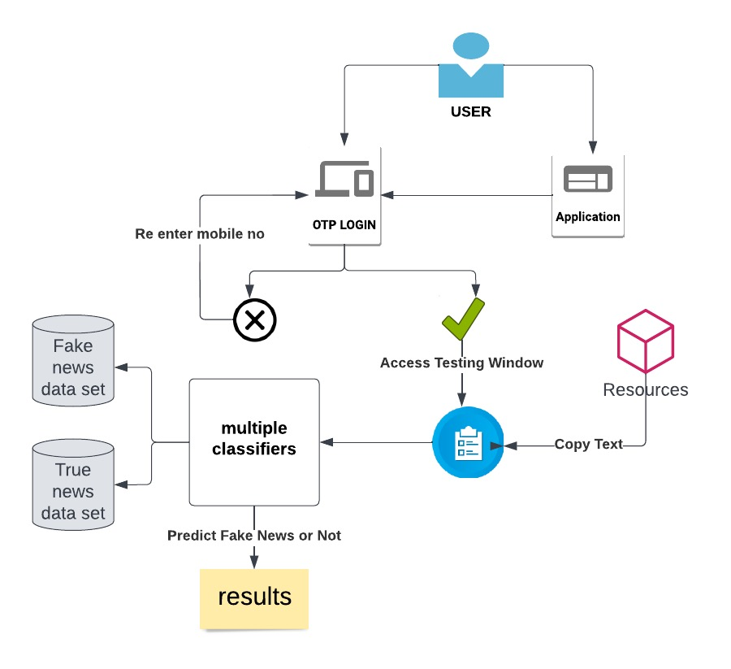

**Fig 4.1 System Architecture**

* + 1. **Work Flow**

1. When the user first launches the application, it will display a welcome page with a start Button.
2. When the user clicks the start button, an OTP screen will appear, prompting the user to input his or her cell phone number.
3. When the user provides his or her mobile phone number, an OTP will be issued to that Number.
4. If the OTP login is successful, the user will be able to access the testing window, which will allow them to determine whether or not the news is fake.
5. By clicking the predict button classifiers window will open.
6. By clicking any classifier, the user can get a forecast for the current news, and by clicking the see all button, the user may see all classifiers.

**CHAPTER 5**

**PROJECT REQUIREMENTS**

**5.1 Hardware Specification**

Processor: 1GHZ Dual core or more

RAM: 4GB or more

Internal Storage: Minimum 300MB Free Space Required

* 1. **Software Specification**

Operating System: Windows, Mac OS, Linux

Development IDE: Spyder

* 1. **Technologies Used**
* Python
* Python Tkinter
* Python Qtdesigner
* Anaconda
* Spyder

**CHAPTER 6**

**MODULE DESCRIPTION**

**Modules**

1. Login Window
2. Test Window
3. Multiple Classifiers
4. Result Window

**Login Window**

* This module is OTP based module.
* User needs to enter the mobile number.
* OTP will generate and user needs to enter the OTP, if OTP is correct then user can the test window.

**Test Window**

* This window contains test box.
* User must type or paste the collected data in the box.
* Test’s the data using various algorithms.

**Multiple Classifiers**

* Logistic Regression, Decision Tree, Gradient Boosting, Random forest, Passive Aggressive classifiers are used and Count Vectorizer also used in this module.

**Result Window**

* In this window the user will obtain the results for the testing data.
* User can check the classifiers one by one and user can check all classifiers at one time.

**CHAPTER 7**

**IMPLEMENTATION**

**7.1 User Interface**

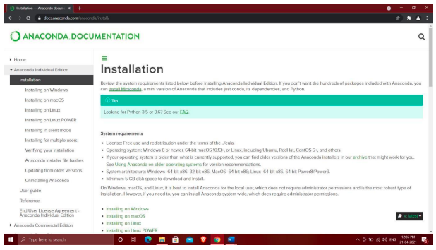

Fig 7.1.1: Installation of Anaconda

Go to the official website of Anaconda and Install the anaconda from the website.



Fig 7.1.2: Choosing of particular OS

Select the particular OS which is needed for the implementation (Downloading windows OS)

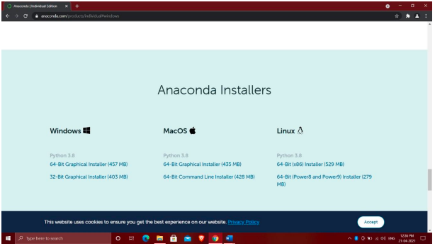

Fig 7.1.3: Selecting Bit processor based on system capacity.

According to the system capacity select the bit processors for the OS.

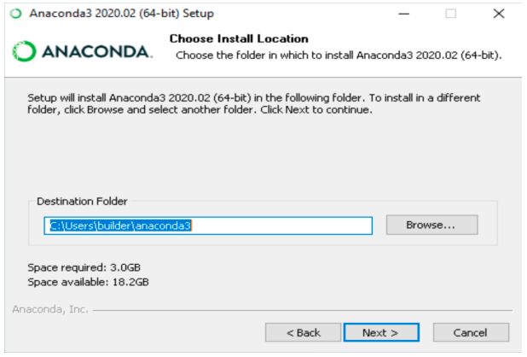

Fig 7.1.4: Choosing destination folder

Select the location to save the downloaded file for the further implementation and make sure the required space was there.



Fig 7.1.5: Adding path to the console.

Add the path to the anaconda for the easy access from the console as the default Python.



Fig 7.1.6: Completion of the setup

Finish the completion of anaconda3 setup and make sure it was connected to the console.

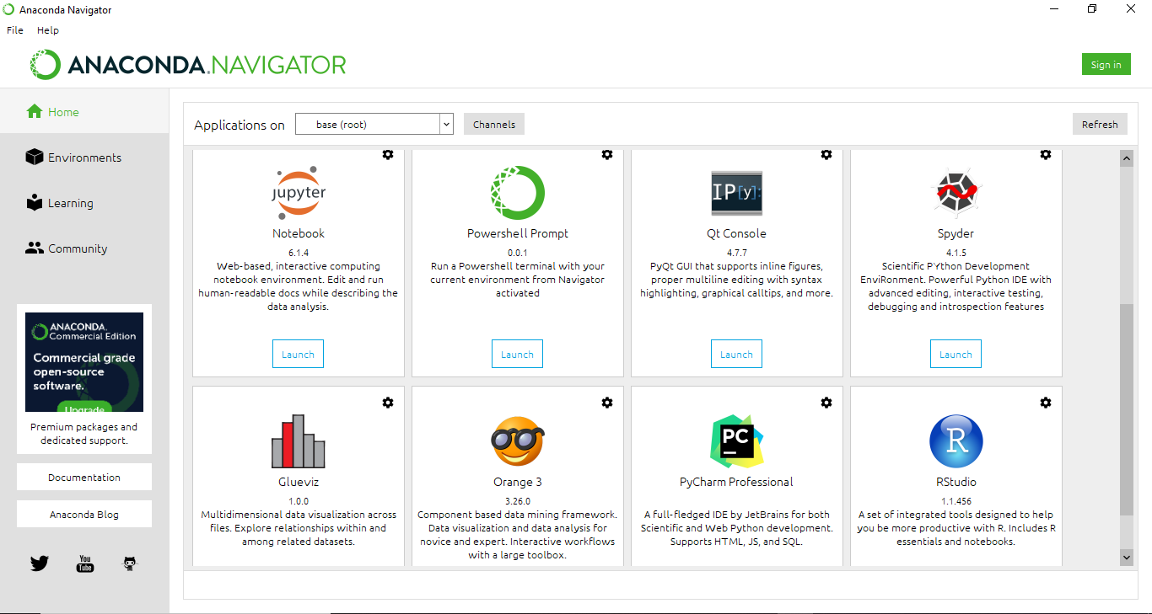

Fig 7.1.7: Launch the Spyder for compiling the program

Launch the Spyder for compiling and running the python program.

Fig 7.1.8: Program edit

Fig 7.1.9: Successful Running of Output

**CHAPTER 8**

**RESULT ANALYSIS**

**8.1 Results Obtained**

We took some paragraphs from the true dataset in-order check the whether the desired output will come or not. After testing the data we got desired output as shown in the given figures.

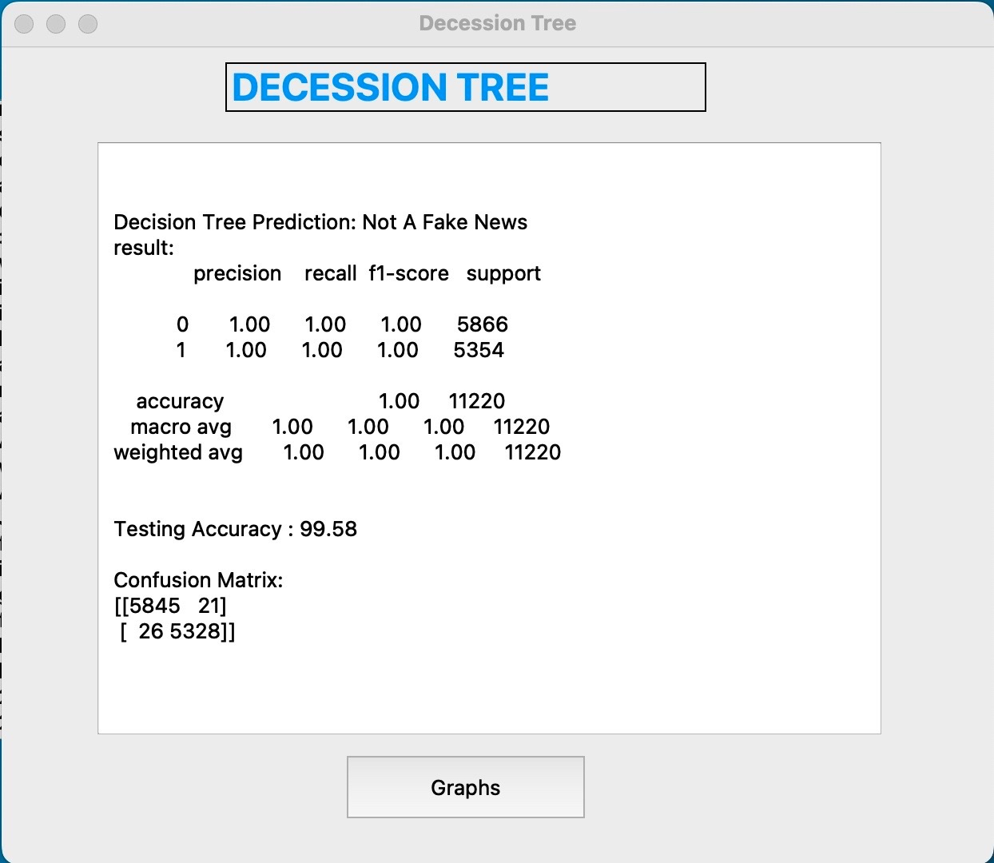

Fig 8.1.1 Decision Tree

By using Decision Tree classifier for the given data in the test box we got it as not fake news and testing accuracy of 99.58.

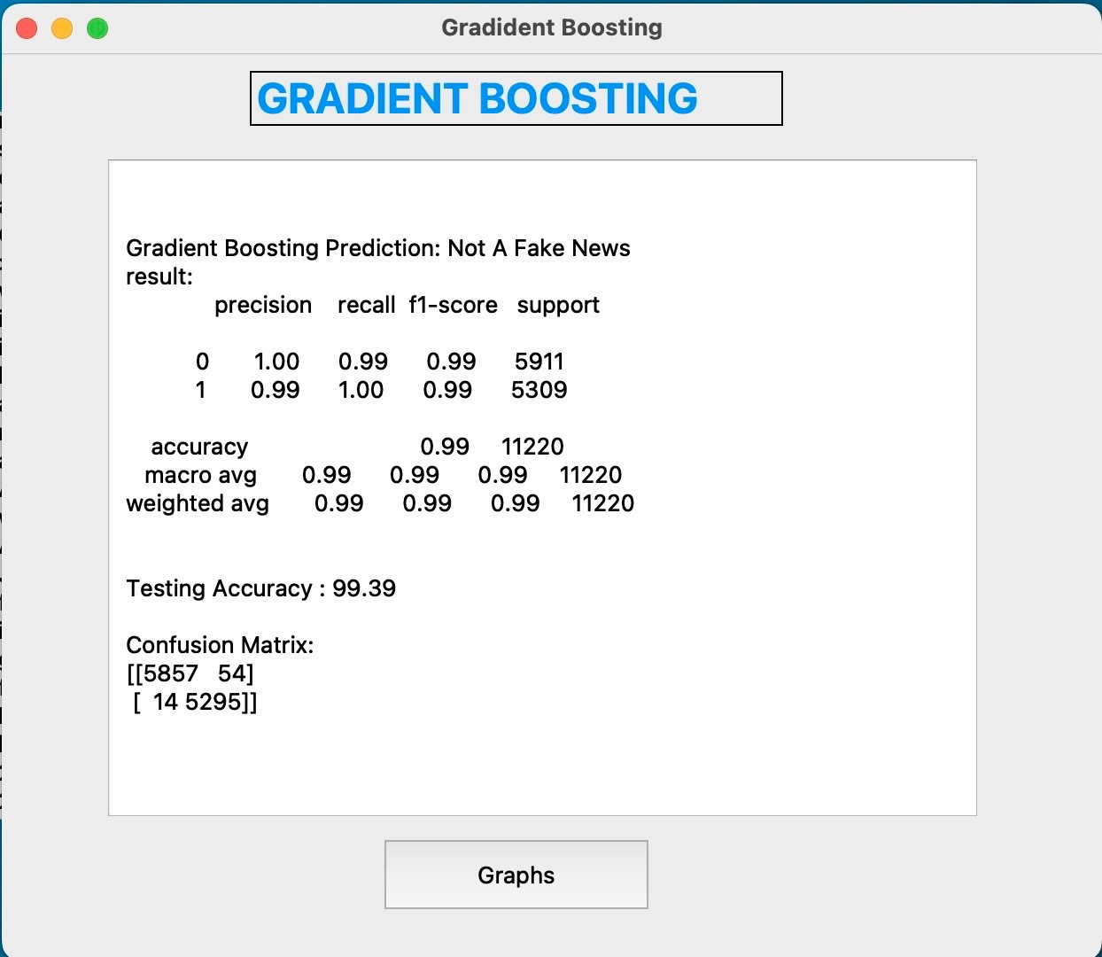

Fig 8.1.2 Gradient Boosting

By using Gradient Boosting classifier for the given data in the test box we got it as not fake news and testing accuracy of 99.39.

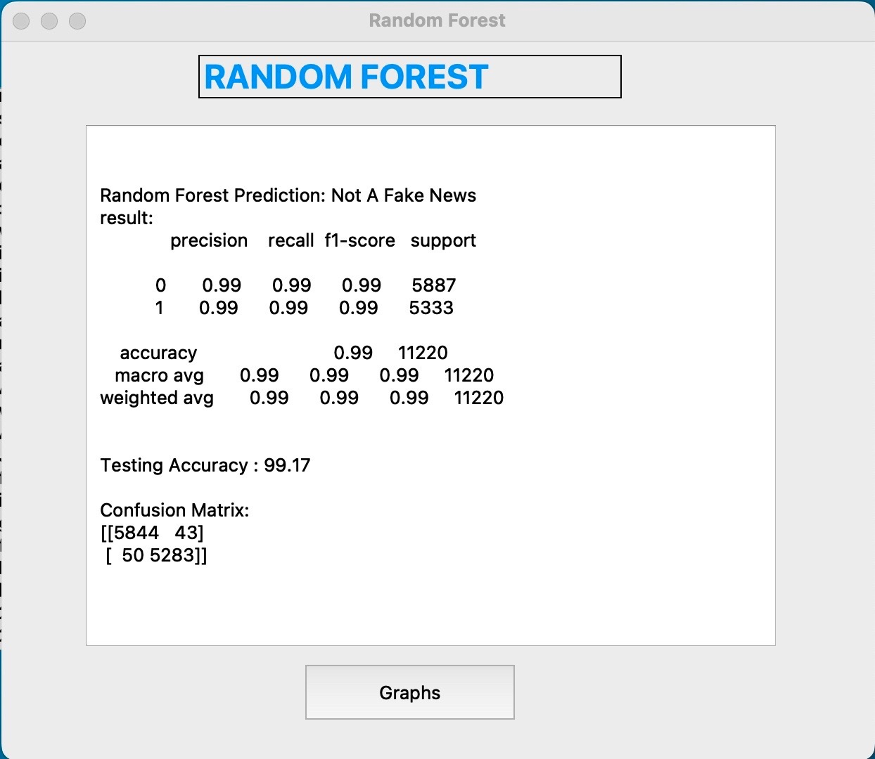

Fig 8.1.3 Random Forest

By using Random Forest classifier for the given data in the test box we got it as not fake news and testing accuracy of 99.17.

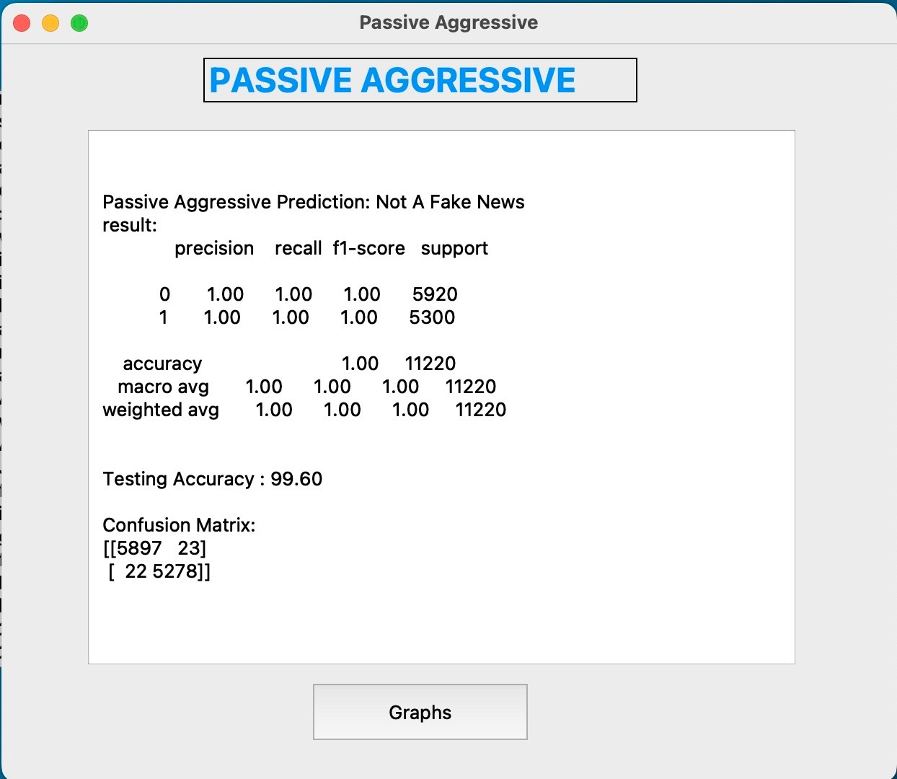

Fig 8.1.4 Passive Aggressive

By using Passive Aggressive classifier for the given data in the test box we got it as not fake news and testing accuracy of 99.60.

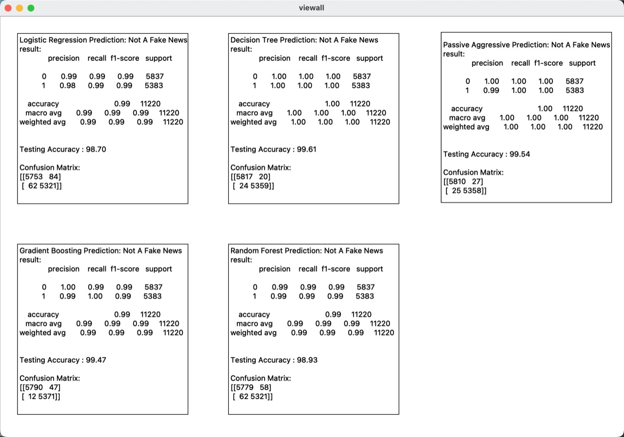

Fig 8.1.5 Multiple Classifiers

The above figure has the all multiple classifiers and values for Precision, Recall, F1-Score, Support and Accuracy.

**CHAPTER 9**

**CONCLUSION AND FUTURE WORK**

**9.1 Conclusion**

* With the help of various machine learning classifiers such as Logistic Regression, Decision Tree, Gradient Boosting, Random Forest, and Passive Aggressive, we have developed a GUI-based application to predict whether the news is "true" or "fake." Moreover, each classifier's results are successful.

**9.2 Future Work**

* Uploading different files (csv, rtf … etc.) into the application.
* Various Machine learning classifiers will be added.
* Showing the visualization of data from the uploaded files.

**CHAPTER 10**

**INDIVIDUAL TEAM MEMBER’s REPORT**

**10.1 Individual Objective**

* Umesh objective was to maintain an updated set for getting more accuracy.
* Sumanth objective was to develop a new friendly user interface.
* Manoj objective was to develop the code and testing.

**10.2 Role of the Team Members**

**1. P. Sai Manoj**

* Architecture diagram
* Modules and Modular descriptions
* Implementation of project code
* Literature review
* References
* Report completion

**2. K. Sumanth Kumar Reddy**

* Abstract
* Objectives
* Literature review
* Existing work and proposed work
* References
* PPT and Report Completion

**3. P. Umesh Chandra**

* Project Idea
* Scope and motivation
* Literature review
* Proposed work
* References
* PPT completion

**10.4 Contribution of Team Members**

* Finding ways to implement the task.
* Splitting up of the document drafts to pitch in each member’s work.
* Contributions in implementing the desired final output.

**References**

* <https://www.google.com/url?sa=t&source=web&rct=j&url=https://aaai.org/ojs/index.php/AAAI/article/view/5389/5245&ved=2ahUKEwj8ysa4tJ_3AhVNXWwGHQ0kAPoQFnoECAsQAQ&usg=AOvVaw3TostF3hhdjhkLCUZLbeGO>
* <https://www.google.com/url?sa=t&source=web&rct=j&url=http://web.cs.wpi.edu/~kmlee/pubs/vo21eacl.pdf&ved=2ahUKEwio-PqVtJ_3AhUYIbcAHYa2BmYQFnoECAcQAQ&usg=AOvVaw3CKbs5iXyobASk9ES2pePz>
* <https://www.google.com/url?sa=t&source=web&rct=j&url=https://people.eng.unimelb.edu.au/jianzhongq/wsdm19-cup-reports/reports/report3.pdf&ved=2ahUKEwisl8nLs5_3AhWnILcAHdB7Dt8QFnoECBQQAQ&usg=AOvVaw3cBS7X6T9lAST5x0cEaB8e>
* <https://www.google.com/url?sa=t&source=web&rct=j&url=http://data.dws.informatik.uni-mannheim.de/fakenews/asonam_short.pdf&ved=2ahUKEwjU9bjzsp_3AhWRS2wGHfX8DrQQFnoECBYQAQ&usg=AOvVaw0_hDaxb3Beih6miikutPYm>
* <https://www.google.com/url?sa=t&source=web&rct=j&url=https://www.albany.edu/~sp191221/publications/Fake_Media_Rich_News_Detection_A_Survey.pdf&ved=2ahUKEwjml5Chsp_3AhVSR2wGHYQTA-QQFnoECAsQAQ&usg=AOvVaw16_cn58lQiFSAyVLcvsNCy>

**APPENDIX A: SAMPLE SCREEN**

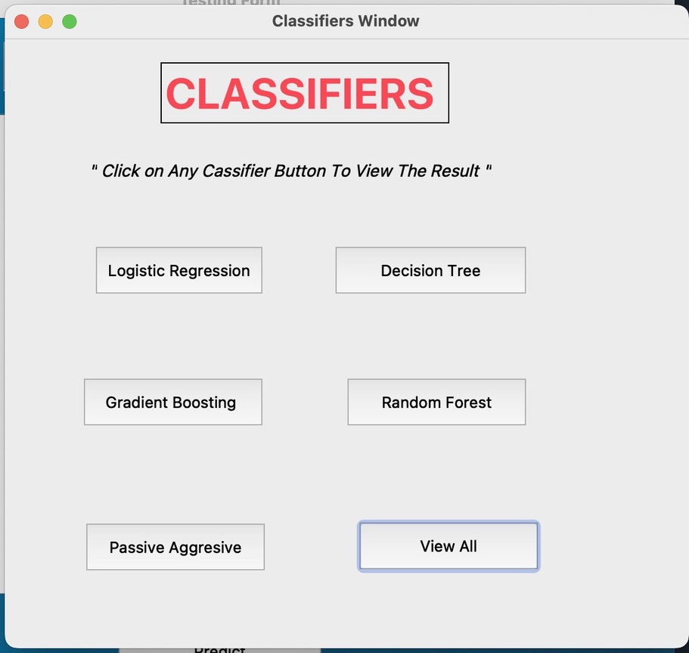

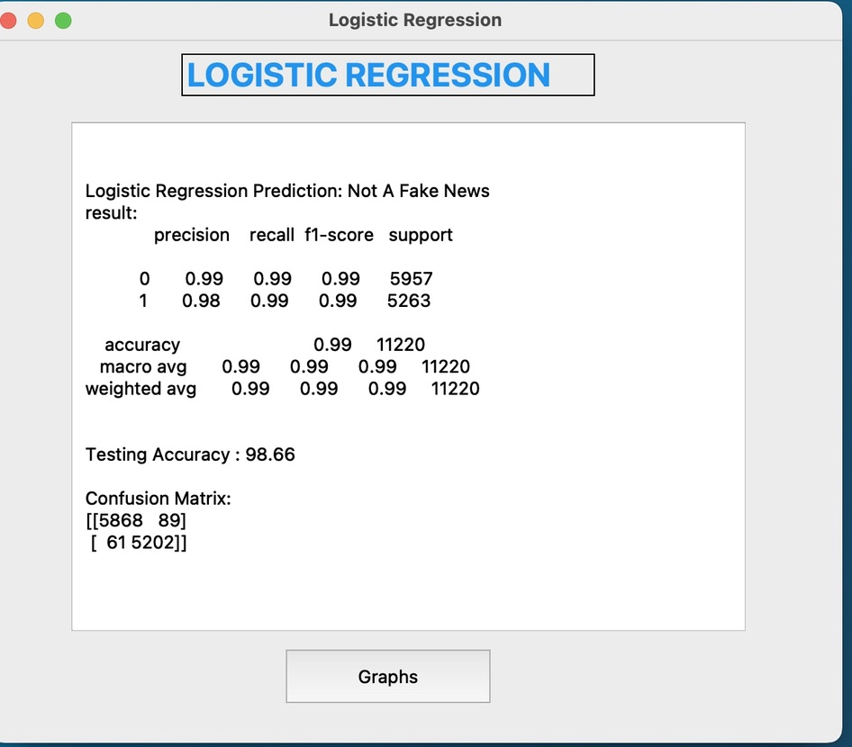

**APPENDIX B: SAMPLE CODE**

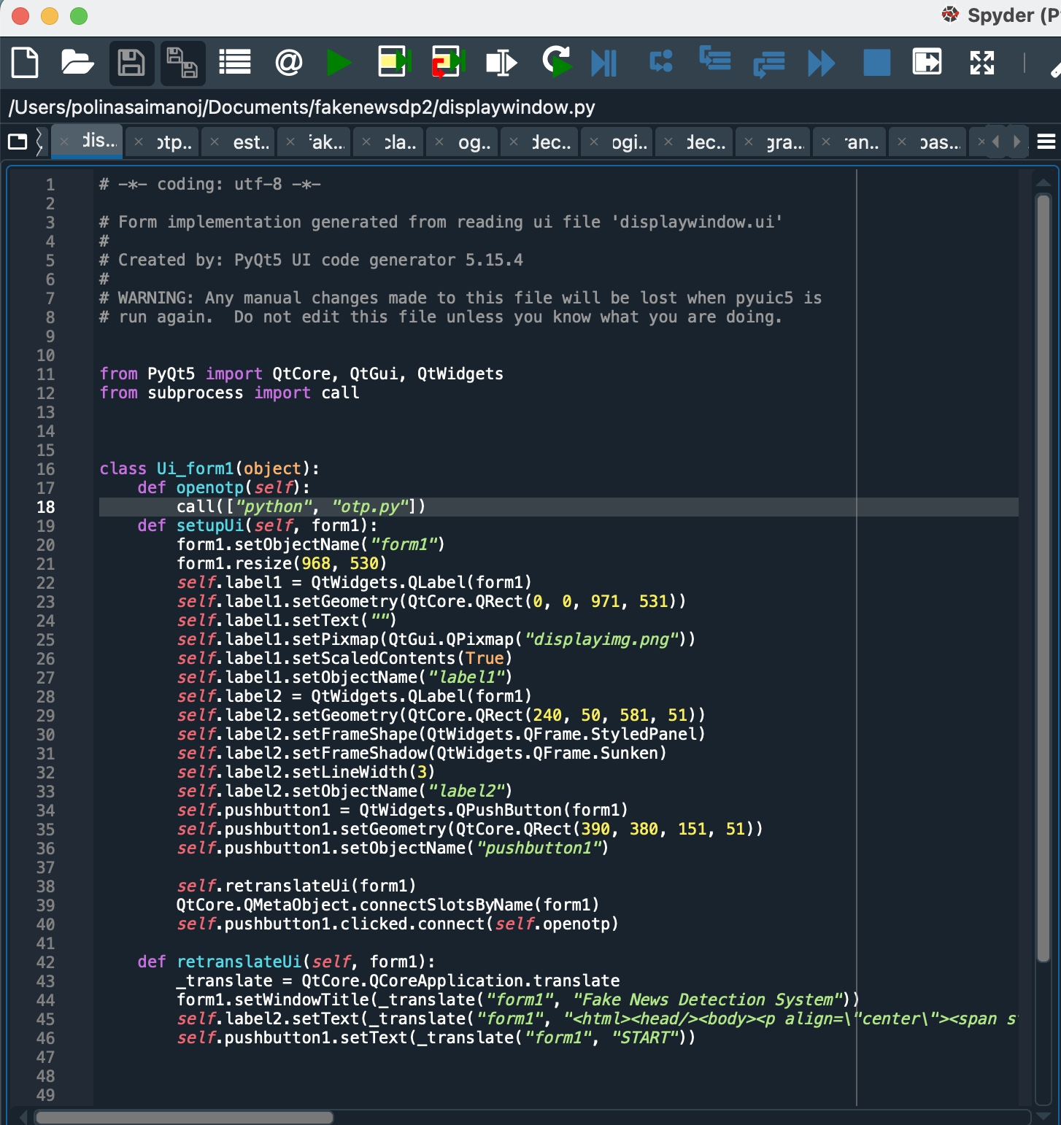

**APPENDIX C: Team Details**

1. **NAME:** P. SAI MANOJ

**CLASS:** CSE 6B

**ROLL NUMBER:** 19113101

**EMAIL:** [**19113101@student.hindustanuniv.ac.in**](mailto:19113101@student.hindustanuniv.ac.in)

1. **NAME:** K. SUMANTH KUMAR REDDY

**CLASS:** CSE 6B

**ROLL NUMBER:** 19113101

**EMAIL:** [**19113105@student.hindustanuniv.ac.in**](mailto:19113105@student.hindustanuniv.ac.in)

1. **NAME:** P. UMESH CHANDRA

**CLASS:** CSE 6B

**ROLL NUMBER:** 19113118

**EMAIL:** [**19113118@student.hindustanuniv.ac.in**](mailto:19113118@student.hindustanuniv.ac.in)